BENEFITS OF NUCLEAR POWER ARE BECOMING OBVIOUS
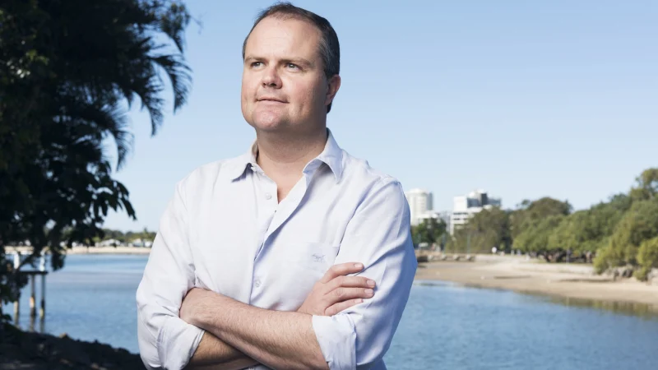
TED O’BRIEN

The Coalition’s technology road map is the next important stage in the energy debate
If our scientists and politicians, along with everyday Australians, can engage in a national conversation about the federal government’s technology investment road map, we will finally break through the perennial stand-off on energy and climate change.
With a discussion paper welcoming active public engagement on different technologies, including small modular nuclear reactors (SMRs), the Coalition government’s road map marks the next phase in the debate.
The importance of a “social licence” to operate a nuclear facility was the biggest lesson learned chairing the recent parliamentary inquiry into nuclear energy. The trust of local communities is paramount. That’s why we recommended a national two-way conversation about the prospect of nuclear energy, and why any approval of nuclear facilities must be subject to the informed consent of the local communities involved.
If we’re to put the Australian people at the centre of the national conversation on energy and climate change, we cannot resort to the old way of framing the debate where climate change is a fight between believers and sceptics, and energy policy is a battle between fossil fuels and renewables.
A contest of ideas is good, but these debates have centred on a false logic. They encouraged a race to the highest moral ground as passions flared and advocates signalled their virtue by claiming love of the environment, support for humankind and protecting our children’s future, but did nothing to help solve the complex generational problems. In contrast, Australians have been spared ideologically divisive debates about COVID-19. Pragmatism and unity are the order of the day.
As restrictions are lifted and we start focusing on issues beyond the virus, it is naive to think political debate won’t reignite over climate change and energy policy. However, that doesn’t mean there isn’t an opportunity to capitalise on the spirit of the times and reset the public conversation on energy.
The technology investment road map takes a system-wide view on low-emissions technologies to deliver a reliable, affordable and cleaner energy mix. And it was right to include modern nuclear technology such as SMRs.
According to the Australian Nuclear Science and Technology Organisation, SMRs could reduce the build cost by shifting most construction offsite to factories for modular manufacturing and could improve safety by using passive safety features and next generation technologies.
Nuclear energy is likely to be the barometer for testing if people are genuine in their desire for a pragmatic and evidence-based debate on Australia’s future energy mix, because no alternative technology carries so much emotional baggage while offering such substantive value.
There has been deep-seated anxiety about nuclear technology in Australia for generations, and it has long been assumed the issue was too divisive to be seriously considered. Whether due to well documented accidents involving older nuclear technologies at Chernobyl and Fukushima — or pop-culture references from Godzilla to The Simpsons — until recently it has been relatively easy to generate community anxiety about nuclear power.
The evidence on nuclear power tells a different story. Nothing surprised me more than to learn, during parliamentary committee hearings, that nuclear is the safest of all energy sources.
According to the Massachusetts Institute of Technology, there have been fewer deaths per unit of energy attributed to nuclear than any other method of electricity generation, including hydro, solar and wind.
No wonder 30 nations collectively use more than 450 nuclear power plants to produce 11 per cent of the world’s electricity, including comparable countries to Australia such as Britain, France, Canada and the US.
Climate change is the game changer. Under the Paris Agreement, we are obliged to reduce our carbon dioxide emissions by 26 per cent on 2005 levels by 2030. As a zero-emission baseload technology, nuclear is the cleanest form of energy on par with renewable sources such as wind and solar, according to the Intergovernmental Panel on Climate Change. In 2018, nuclear power plants around the world produced 50 per cent more clean electricity than wind and solar combined.
Rather than being perpetually divisive, I believe nuclear technology has the capacity to unite Australians. It is a proposition that brings together progressives and conservatives within the Coalition. Likewise, within the Labor movement, the Australian Workers Union and the Construction Forestry Maritime Mining and Energy Union have been calling for nuclear energy to be on the table for consideration.
Now a test of leadership lies ahead for Anthony Albanese. Will the Opposition Leader tip his hat in favour of a sensible national conversation with the Australian people, or will he return to the politics of old and run a “not in my backyard” scare campaign?
With so much at stake, we must hope that the public applies old fashioned Australian pragmatism: let’s hear the evidence before knocking it.

Ted O’Brien is federal member for Fairfax and chairman of the House of Representatives standing committee on the environment and energy.
Nothing surprised me more than to learn … that nuclear is the safest of all energy sources

