POSCO has options and doesn't need Hume coal and the New South Wales Government must reject the Hume Coal Development.
From Robert and Ann Parker,
21 Old Mandemar Road, Berrima, NSW 2577 23rd June, 2017
Outline:
POSCO's subsidiary Hume Coal intends to extract coking coal for steel making and also thermal coal from a mine near our village of Berrima in New South Wales. This will amount to 39 million tonnes of coal whose combustion will produce 102 Million tonnes of carbon dioxide pollution over the 23 years of the life of the mine. This is in addition to the 1.8 million tonnes of scope 1 and 2 emissions generated during the life of the mine.
POSCO states in their 2015 report that Climate Change which is caused by the burning of these fossil fuels is a megatrend affecting all corners of society. The greenhouse gas emissions from this coal will directly threaten the future of our children, grandchildren and future generations through the impact of greenhouse gas emissions leading to dangerous global warming.
The company knows the criticality of this because in November 2009 their owner, South Korea's POSCO declared plans to eventually halt carbon emissions by switching to a hydrogen-based steelmaking process from 2021. That's only four years away.
Their stated ultimate goal is to produce steel using hydrogen produced by nuclear reactors to replace coal. Japan has designed a suitable meltdown proof Very High Temperature Reactor (VHTR) and China will commission in 2017 a similar High Temperature Gas Cooled reactor the HTR-PM.
POSCO has viable options, doesn't need more coking coal and publicly admits that its operations are causing global warming and does not need the production from the Hume Coal operations.
The future is with POSCO's stated commitment to nuclear energy using hydrogen reduction.
The New South Wales government has documented commitments to the protection of the environment and the security of current and future generations through inter and intra generational equity.
The New South Wales Government is requested to reject the Hume Coal development on the basis of its impact on dangerous global warming leading to Climate Change.

Introduction
POSCO's subsidiary Hume Coal intends to extract coking coal for steel making and also thermal coal from a mine near our village of Berrima in New South Wales. This will amount to 39 million tonnes of coal whose combustion will produce about 102 Million tonnes of carbon dioxide pollution over the 23 years of the life of the mine. This is in addition to the 1.8 million tonnes of scope 1 and 2 emissions generated during the life of the mine. The greenhouse gas emissions from this coal will directly threaten the future of our children, grandchildren and future generations and all other species on the planet through the impact of greenhouse gas emissions leading to dangerous global warming.
The New South Wales Government owns the mineral resource and is considering allowing it to be mined in the knowledge that it will produce carbon dioxide emissions and exacerbate global warming. At this stage its intended destination is unstated but is for either export or domestic use.
The time frame for decarbonisation of Australia's economic activity was outlined in Chapter 12 of the Garnaut report which summarises the findings of various Intergovernmental Panel on Climate Change reports. The time scale for emissions reductions is shown in figure 12.1 "Australia's emissions reductions trajectories to 2050. This same time scale also applies to Korea and internationally.
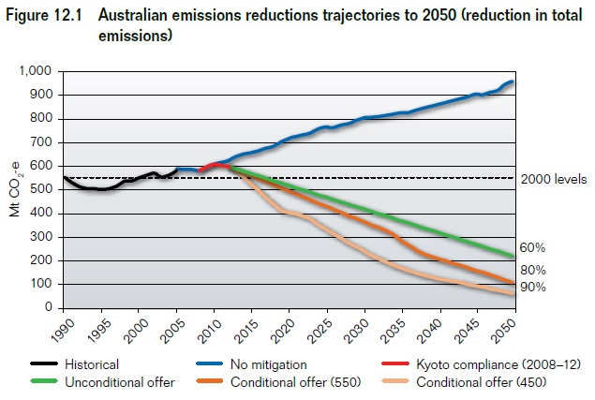

As POSCO tell us in their 2015 report, Climate Change which is caused by the burning of these fossil fuels is a megatrend affecting all corners of society. They outline measures they are taking to address global warming which have been imposed upon companies operating in Korea through their "Act on the Allocation and Trading of Greenhouse Gas Emission Permits".
Currently to make steel iron ore is melted in a blast furnace using super-heated air from burning coal. In addition to its role as a fuel, coal is also used as a critical component in steel production because the carbon from burning coal captures oxygen from the molten iron ore, emitting carbon dioxide in the process. This is known as "reduction". New technology is being developed to use hydrogen instead of coal so that the output is steam instead of carbon dioxide.
No steelmaker uses the hydrogen steelmaking process yet, however serious research into its use is being carried out in Europe, the USA, Korea, China and Japan
In 2009 Choi Doo-jin, a senior spokesman at POSCO stated that "We are currently studying the hydrogen-steelmaking process. We hope to get hydrogen gas from small or mid-sized nuclear reactors, which are also under study by us."
POSCO officials said the steelmaker is considering supplying hydrogen gas from its "SMART" nuclear reactors. It is looking at participating in a consortium for developing small or medium-sized nuclear reactors.

Role of The New South Wales Government
The New South Wales Government as owner of this resource has an over-riding obligation to protect the environment and meet the obligations of intergenerational equity.
These obligations are spelled out in a number of pieces of relevant legislation including the three following key instruments:
- Protection of the Environment Operations Act 1997 in which under para 3 - Objects of the Act obligations are outlined to to protect, restore and enhance the quality of the environment in New South Wales, having regard to the need to maintain ecologically sustainable development.
This act also has the objects of to reduce risks to human health and prevent the degradation of the environment by the use of mechanisms that promote the following:
(i) pollution prevention and cleaner production,
(ii) the reduction to harmless levels of the discharge of substances likely to cause harm to the environment,
(iia) the elimination of harmful wastes,
- Environmental Planning and Assessment Act 1979 in which under Para 5 - Objects of the Act are to encourage
  - the proper management, development and conservation of natural and artificial resources, including agricultural land, natural areas, forests, minerals, water, cities, towns and villages for the purpose of promoting the social and economic welfare of the community and a better environment,
  - the protection of the environment, including the protection and conservation of native animals and plants, including threatened species, populations and ecological communities, and their habitats, and
  - ecologically sustainable development

- Protection of the Environment Administration Act 1991 which outlines the objectives of the Environmental Protection Authority which include but are not limited to:
  - to protect, restore and enhance the quality of the environment in New South Wales, having regard to the need to maintain ecologically sustainable development; and
  - to reduce the risks to human health and prevent the degradation of the environment, by means such as the following:
    - promoting pollution prevention;
    - adopting the principle of reducing to harmless levels the discharge into the air, water or land of substances likely to cause harm to the environment;
    - minimising the creation of waste by the use of appropriate technology;
For the purposes of subsection (1) (a) of the Act , ecologically sustainable development requires the effective integration of economic and environmental considerations in decision-making processes. Ecologically sustainable development can be achieved through the implementation of the following principles and programs:
- The precautionary principle—namely, that if there are threats of serious or irreversible environmental damage, lack of full scientific certainty should not be used as a reason for postponing measures to prevent environmental degradation.
- Inter-generational equity—namely, that the present generation should ensure that the health, diversity and productivity of the environment are maintained or enhanced for the benefit of future generations,
- conservation of biological diversity and ecological integrity—namely, that conservation of biological diversity and ecological integrity should be a fundamental consideration
Should Hume Coal's mining operations be allowed to proceed the Government of New South Wales by approving that operation will be in breach of the intent of these three major pieces of legislation and will have directly contributed to the addition of about 104 million tonnes of carbon dioxide to the atmosphere.

POSCO's Performance
We consider that the New South Wales Government should be encouraging POSCO to significantly reduce their carbon dioxide emissions. So, after including 16 pages of commentary on global warming in their 2015 annual report how does POSCO's actual performance compare to International practice? Well at present their pace is slow.
Reference to Figure 1 from the World Steel Association shows that for a group of steel manufacturers who chose to provide data both emissions intensity and energy intensity for steel making are on the rise worldwide. It can only be supposed that those companies who chose not to report have emissions which exceed the industry averages.
Reference to Figure 2 shows that in 2015 the company had an emissions intensity of 1.91 tonnes CO₂/tonne of crude steel - about the industry average while its energy intensity was 21.9 GJ/tonne or just above the industry average.

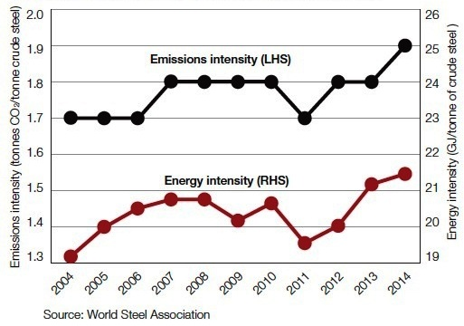
Figure 1 - Steel Industry emissions and energy use
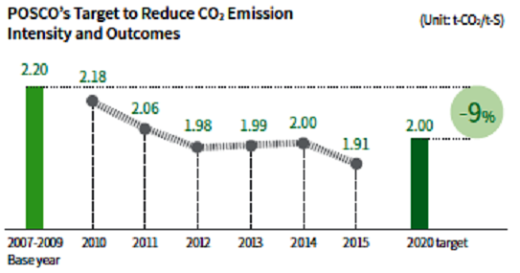
Figure 2 - POSCO's Emissions reduction target
Since 2009 POSCO's emissions reductions have declined slowly from 2.18 tonnes CO2/tonne crude steel which was well above industry best practice. While they are in line with the reductions shown in the Steel Industry's stated goals as shown in Figure 3 for a 2 degree transition pathway they are not in line with a 1.5 degrees warming scenario. Nor are they in line with the commitment made by POSCO in 2009 to switch to hydrogen based steel production by 2021.
POSCO's stated aim in 2020 is to achieve a voluntary emissions intensity of 2.00 CO₂/tonne crude steel.

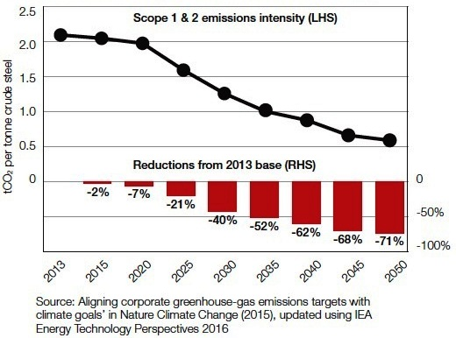
Figure 3 Steel Industry 2 degree transition pathway
Its abundantly clear that with the approval of the HUME coal mine and its production continuing out to 2040, POSCO has no intention of either embracing zero carbon emissions steel making or meeting even a 2 degree transition pathway shown in Figure 3.
In summary therefore POSCO's self imposed target by 2020 is now higher than their current performance. It's worth questioning why POSCO cannot have a target in 2020 at least in line with Swedish steel maker SSAB of 1.7 CO₂/tonne crude steel.

Solutions
In objecting to the approval of mining the HUME coal deposit we fully acknowledge the vital place for future steel production. This must however take place without the traditional use of fossil fuels.
The solutions to greenhouse gas emissions in the steel industry come from either sequestering the carbon dioxide which is not a promising technology or by using hydrogen reduction as acknowledged by POSCO.
Currently industrial hydrogen is produced in a process known as steam reforming and takes place by mixing steam with methane at high temperatures. It's an energy hungry process that produces carbon dioxide as well as the hydrogen and is of no benefit for emissions reductions.
Hydrogen steelmaking uses hydrogen (H₂) as a reduction agent and fuel instead of the carbon in coal. It uses oxygen (O₂) for the burning of that fuel and refining of steel in the electric arc furnaces. This can be made with no carbon emissions using a water splitting process. Two main routes exist namely:
- Electrolysis using electricity to split the water into hydrogen and oxygen or,
- Thermo-chemical where a combination of several reactions proceed at high temperatures to produce hydrogen such as the iodine–sulphur (IS) and copper-chlorine (CuCl) processes.
Both methods proceed more efficiently at elevated temperatures of variously between 450 to 950 ºC. The energy demand of the method can be supplied from a nuclear heat source such as a Very High Temperature Reactor (VHTR) or High Temperature Gas Reactor (HTGR). Integrating the nuclear heat source, the thermo-chemical hydrogen production process and the hydrogen steelmaking process means we can produce iron with extremely low CO₂ emissions.

Reactor Types

VHTR
The VHTR has been developed for several decades mainly in nuclear research institutes where the Japan Atomic Energy Agency (JAEA) has studied them most intensively.
The VHTR is an advanced high temperature gas-cooled reactor (HTGR) featuring 950 ºC of high temperature helium gas coolant and graphite moderators in the core. The VHTR can supply both high temperature heat through an intermediate heat exchanger and electricity with a helium gas turbine simultaneously. Therefore, both the heat and electricity requirements of the efficient iodine–sulphur process and steelmaking process can be supplied by the VHTR. JAEA examined the applicability of several nuclear reactor types for hydrogen steelmaking was compared and VHTR was selected as the most promising. The hydrogen producing IS process has temperature requirement exceeding 850 ◦C which is attainable by the VHTR.
The hydrogen and oxygen are supplied directly to furnaces from reactor using piping because VHTR can be installed near the steelmaking plant due to its inherent safety especially against melt-down.
POSCO's endorsement of this concept is shown in Figure 4 - POSCO's 2013 time frame to low emissions steel making Figure 4 - POSCO's 2013 time frame to low emissions steel making
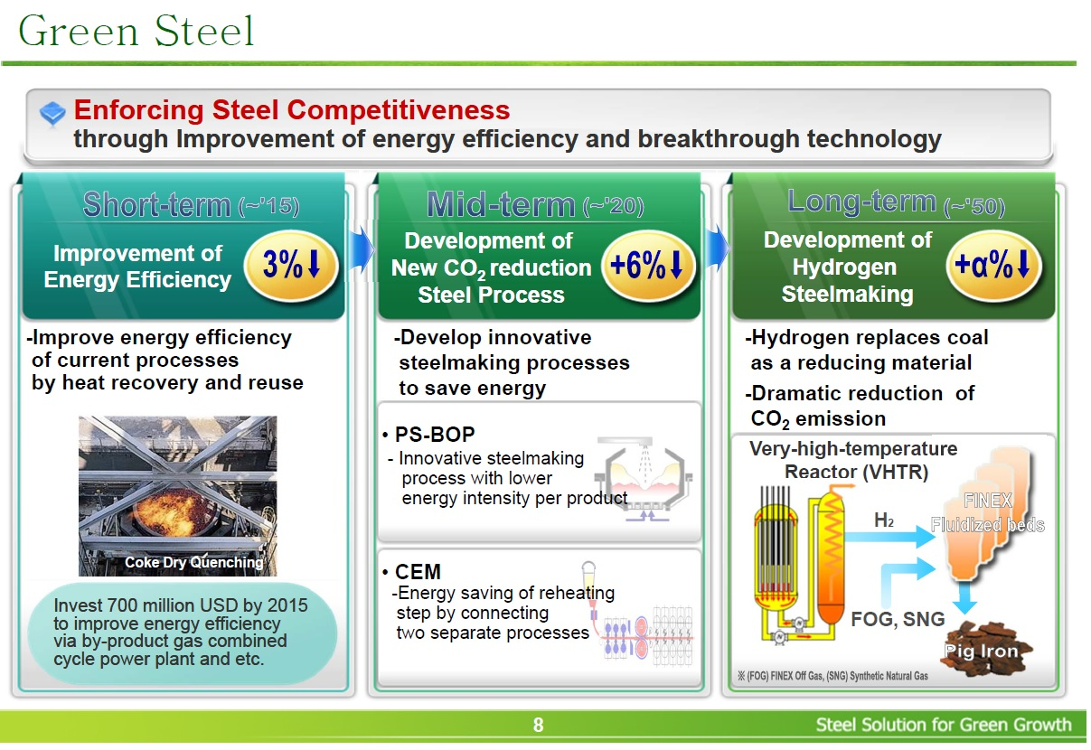
Figure 4 - POSCO's 2013 time frame to low emissions steel making

HTGR
Next year in China the first large scale High Temperature Gas cooled reactor using the pebble bed concept will be commissioned. Known as the HTR-PM this ground breaking innovation follows the successful operation of the HTR-10 demonstration unit.
These reactors can be installed in groups to generate power levels equal to our large coal fired plants. The lower power density, coated particle fuel performance and a balanced system design ensures that the fundamental safety functions are maintained. Consequently the HTR-PM needs no emergency core cooling systems as the decay heat is removed by natural mechanisms in case of emergency.

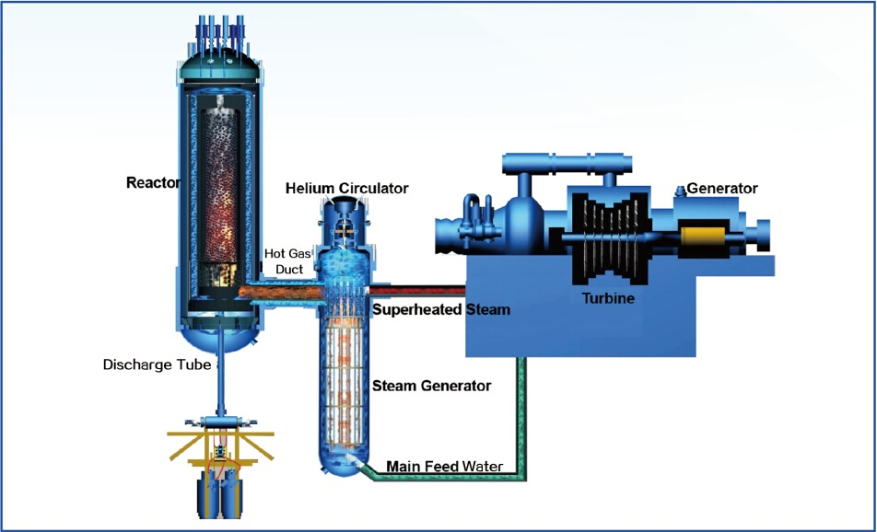
Figure 5 - layout of HTR-PM electricity generating plant

Conclusion
The success of the HTR-PM will underpin future low carbon industrial applications including hydrogen production for steel manufacture, desalination and transport fuels.
POSCO already has the FINEX process which it first deployed over a decade ago and produces steel using thermal instead of coking coal. FINEX is an innovative iron making process that directly uses iron ore fines and non-coking coal, replacing conventional blast furnaces. It is however only an intermediate technology because its carbon emissions reductions are only minor.
The future is with POSCO's stated commitment to nuclear energy using hydrogen reduction
Neither of these options have any use for coking coal and POSCO does not need the production from the Hume Coal operations.
The New South Wales government has documented commitments to the protection of the environment and the security of current and future generations through inter and intra generational equity. As POSCO, the proponent of the Hume Coal mines has stated Climate Change which is caused by the burning of these fossil fuels is a megatrend affecting all corners of society.
The New South Wales Government is requested to reject the Hume Coal development on the basis of its impact on dangerous global warming leading to Climate Change.

