Fukushima Province Visit - May 2017
by Robert Parker
In May 2017 I visited a number of regions in the Fukushima province in Japan that had been contaminated by the meltdown of three reactors in 2011. The regions included Iitate, Katsurao, Minamisoma as well as Fukushima City.
My interest in nuclear energy comes from a strong belief that it will form the backbone of any effective decarbonisation in our economy and this is reinforced by respected researchers such as Dr James Hansen. So, how do I reconcile events such as the meltdowns with the need to address global warming having lost confidence in the reporting by our media? I decided to go to Fukushima in person to learn more about that community.
With this in mind I set out on this journey with my little Gamma Scout radiation detector and spent three days looking at the impacts upon the local populations. I was also given a good briefing in Fukushima City by the technical advisor for the Fukushima Office of Environmental Restoration. My visit did not include any aspects of the power station itself.
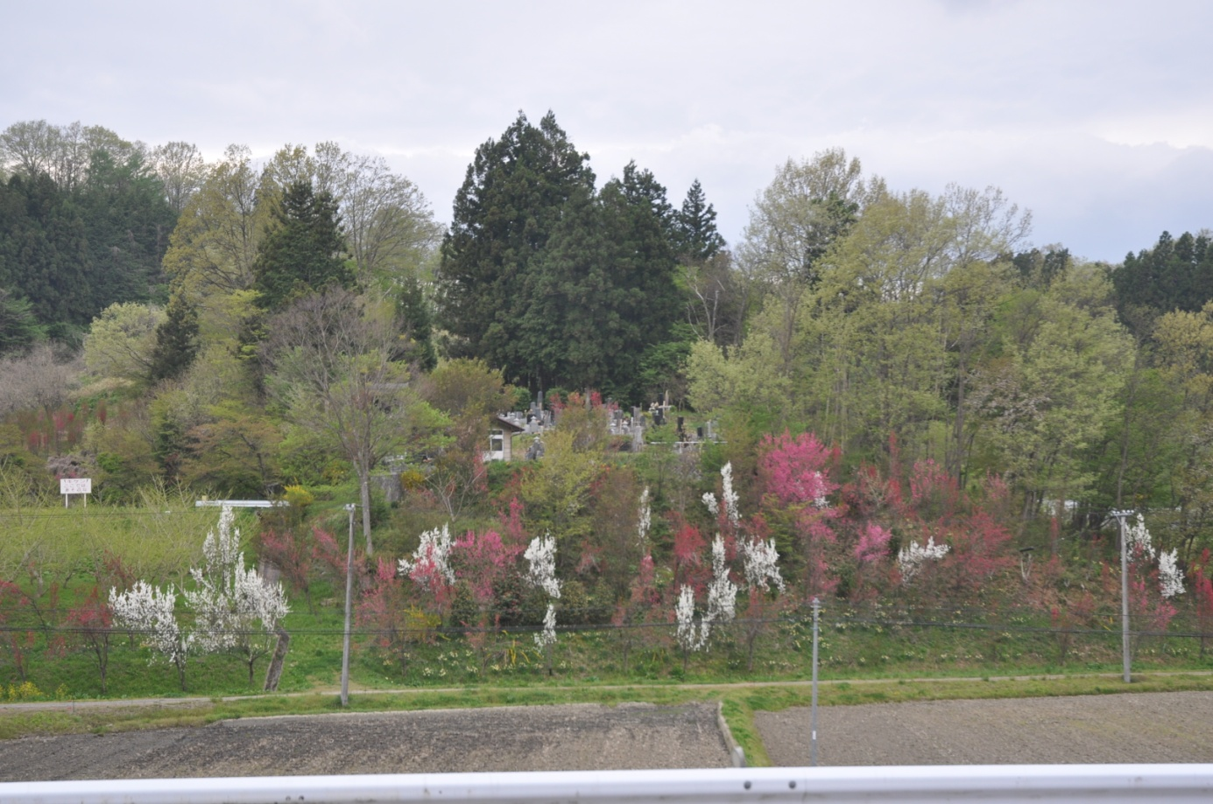
Figure 1 - Fukushima Landscape
The accident at the Fukushima Daiichi Nuclear Power Station in March 2011 severely disrupted agriculture in north east Japan, especially in Fukushima prefecture. This has historically been a flourishing agricultural region producing rice, vegetables and livestock. It was the fourth largest rice producer in Japan before the accident.
This prefecture has significant natural beauty with a cool temperate climate and high rainfall. It is hilly country with winter snow and well defined seasons. Intensive agriculture is carried out in paddy fields in the valleys where rice is traditionally grown. Villages line the main roads and farming hamlets and orchards are located higher up in the valleys.
In this article I have used some units that need explanation but first we'll look at the comparative radiation doses and their impacts upon people. You'll notice from this table how extremely low the radiation doses in Fukushima really are.
 |  |  | Dose in mSv
50% fatal within a month |  |  | 5000
Causes radiation sickness but not death |  |  | 1000
Dose below which no evidence of health impacts is observed |  |  | 100
Limit for nuclear industry workers and miners |  |  | 20
Background in parts of Kerala, India, Less cancer than Australia |  |  | 4 - 70
Aircrew operating polar routes |  |  | 9
Average Natural background to US citizen |  |  | 3.1
Radiation in office in Berrima NSW |  |  | 1.52
My flight Sydney/Tokyo return totalled 0.03mSv or 3 times the radiation I received in Fukushima province |  |  | 0.03
My three days in Fukushima and contaminated zones totalled 0.0093mSv |  |  | 0.0093
Annual additional dose in Fukushima in 2016 to 98% of survey |  |  | <1 mSv
Dose due to ingested caesium in 99.9% of Fukushima resident's tests with 300Bq threshold dose |  |  | <0.01mSv
Results of External exposure survey for children 15 years old and less in Fukushima
Average additional exposure dose
 | 2011 | 1.05
 | 2012 | 0.56
 | 2013 | 0.44
 | 2014 | 0.32
Accumulated 100 year dose over and above background due caesium 134 and 137 at Fukushima City |  | Approx 10
Accumulated 100 year dose due to background in Fukushima City at 2.4mSv/yr |  | Approx 240
Table 1 - Comparative Radiation doses
A Becquerel or Bq is a unit used to measure radioactivity. One Becquerel is equal to one nuclear decay in one second and is an incredibly small number. Often radioactivity is expressed in larger units such as thousands (kBq), millions (MBq) or billions (GBq) of Becquerels. Throughout this article I have referred to Bq/kg and this means the number of radioactive nuclei that decay in each second per kilogram of the host material.
Not all Bequerels were created equal. The energy released by the decay of a caesium 137 nucleus for example is much higher than from a radioactive hydrogen nucleus such as tritium. Therefore if we ingest 1 kilogram of rice with say 5000 Bq/kg of caesium 137 we will receive 555 times more energy from radiation than from 1 litre of tritiated water with 5000 Bq/kg.
We have a new unit to measure the effect of this energy difference on our bodies and it's called the Sievert. This is a large unit and so the milliSievert or mSv is more convenient. The ingestion of that tritiated water with 5000 Bq/kg will give us an effective radiation dose of 0.0001mSv while the 1 kg of rice will give us 0.05mSv.
Our normal background radiation in Australia is about 1.5 mSv per year and there is no statistical evidence of medical harm being done to people at radiation levels below 100 mSv above background.
Following the accident the government of Japan, under the Food Sanitation Act, instituted new limits on the amount of the most common radioisotopes released by the reactors, namely caesium 134 and 137, that could be present in food. On 1 April 2012, the internal radiation dose limit received from radiocaesium in food was reduced from 5 mSv/yr to less than 1 mSv/yr.
This meant the radiocaesium concentration in general food (except foods for infants) was set to be below 100 Bq/kg which was down from the provisional regulation value of 500 Bq/kg.
This value of 1mSv/yr is an important policy limit. As mentioned earlier there is no statistical evidence of harm at 100 times this value however this low value is adopted internationally as the maximum incremental increase that the public can be exposed to by a nuclear activity.
Radiocaesium has been singled out because there has been no increase in levels of strontium 90 or other isotopes that give rise to public health concerns. Through an extensive study into the mechanism for transfer of radiocaesium to plant species it was recommended that the most appropriate method to re-establish agriculture was to remove the top 50mm layer of topsoil from affected paddy fields where the radiocaesium level exceeded 5000 Bq/kg. For the soils contaminated from 5000 to10,000 Bq/kg, replacing the topsoil with non-contaminated subsoil by soil inversion is an optional strategy in order to sequestrate contaminated soil from crop root zone.

The decontamination is being carried out in municipalities which have been designated as Intensive Contamination Survey Areas and are shown in Figure 2.
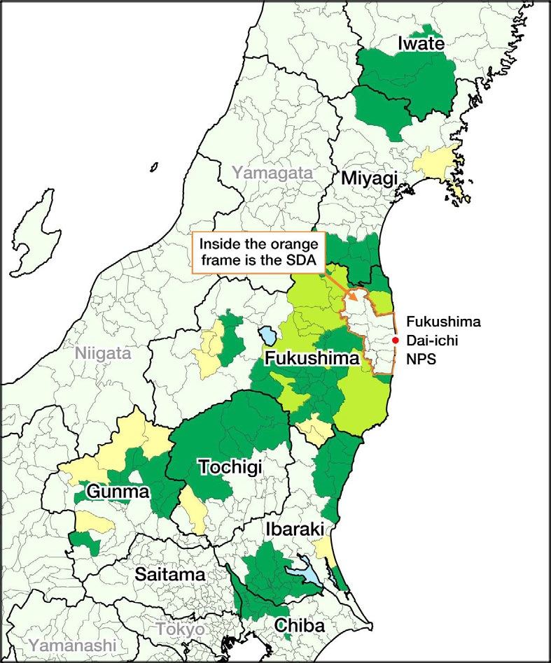
Figure 2 - Intensive Contamination Survey Areas
In these local government areas it is the municipality itself which actually carries out the decontamination work. These survey areas surround the region of more intense contamination called the Special Decontamination Area (SDA) which was subject to evacuations following the meltdowns. Decontamination in this SDA which is shown in Figure 3 is implemented by the national Government.
I stayed in Fukushima City which is north west and outside the SDA. Following the meltdowns the air dose rate peaked at 24 mSv/yr in the city but within a year had dropped to 8.8 mSv/yr and is now at 1.5mSv/yr or less than the value of 1.72 in my office in Berrima NSW.
Natural decay of caesium does not account for this 94% reduction. In this time scale it can only account for a 13% reduction and so the remainder is due to the $40 billion decontamination programme and natural removal by rainfall. The widespread airborne radiation reductions in and around the Fukushima prefecture are shown in Figure 6.

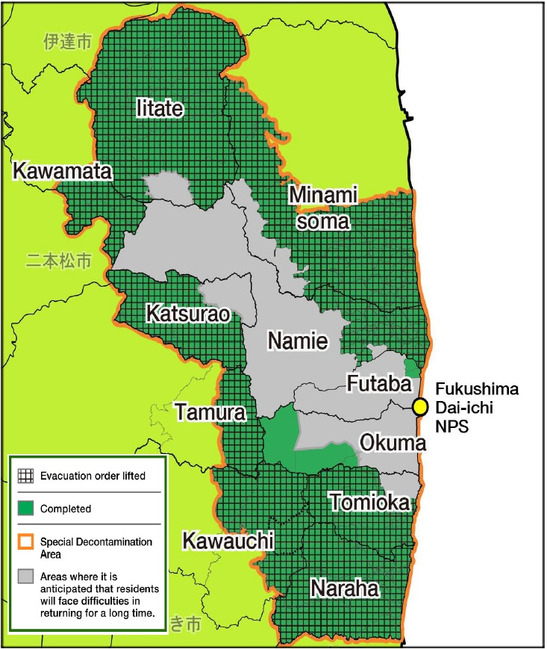
Figure 3 - Special Decontamination Area (SDA)

Fukushima city is busy and bustling. Restaurants and shops are well patronised, though judging by the hotel tariff of around $70/night and the sighting of only one other European during my stay, tourists are thin on the ground.
Moving out into the Special Decontamination Area the vitality of communities varies according to the time since decontamination was completed and possibly their natural economic vitality. Evacuees from small agricultural communities will, in the preceding five or six years, have found new jobs and directions in life.

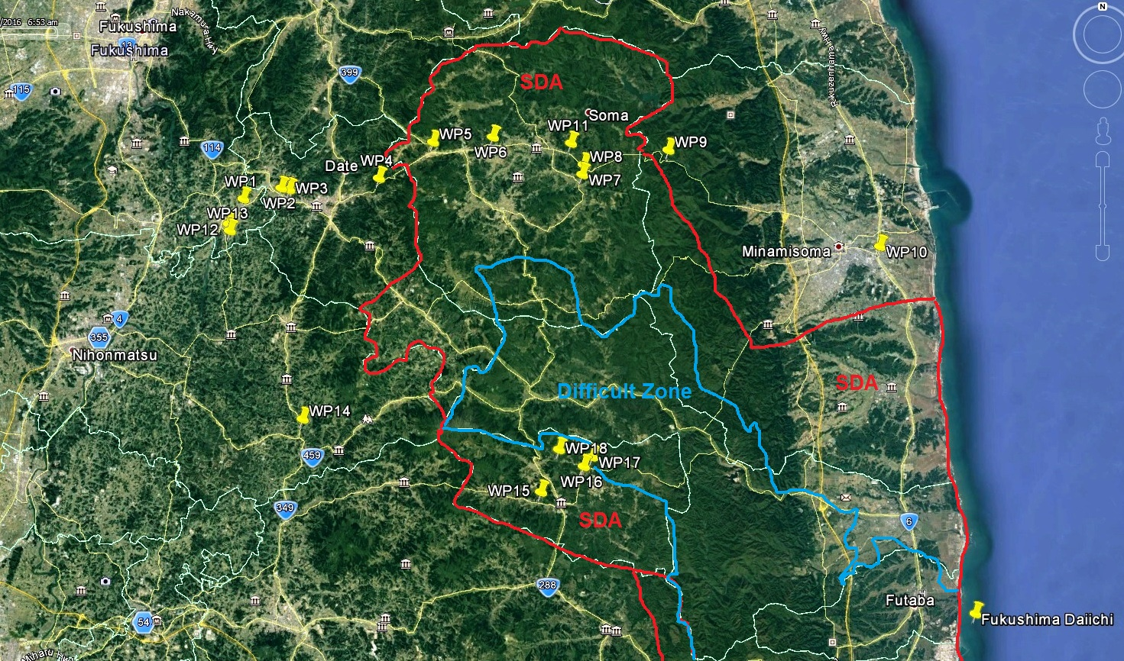
Figure 4 - Points visited in relation to Special Decontamination Area
The impetus to restore agriculture in the region is well underway with a huge campaign to scrape off the top 50mm or so of topsoil which contains the radioactive caesium . So far around 22 million cubic metres of material has been stockpiled in interim storage locations such as that shown in Figure 5.
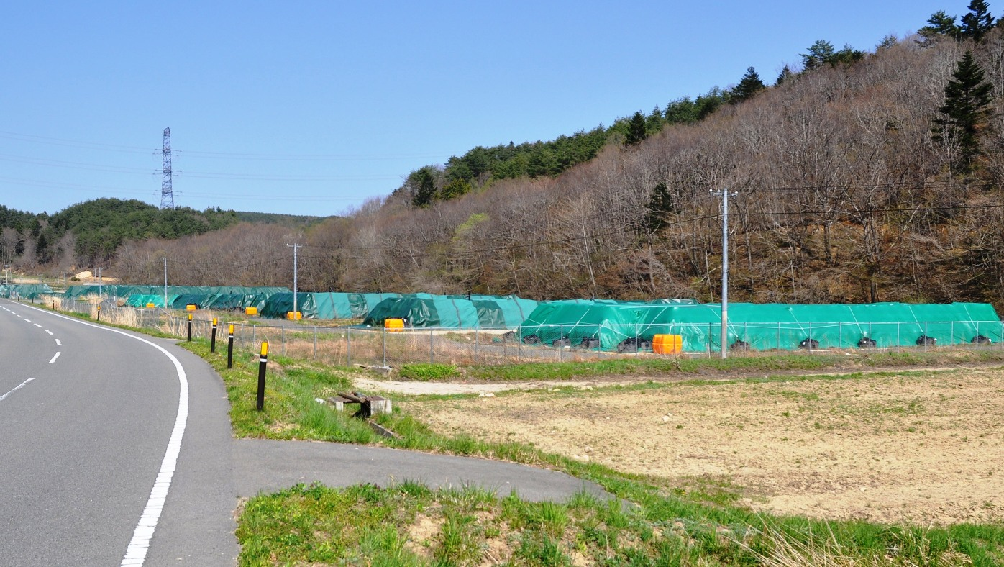
Figure 5 - Interim Storage of stripped material
While crops are being planted in the outer Intensive Contamination Survey Areas within the more contaminated SDA, at locations such as Katsurao or Iitate villages, things are proceeding more slowly. Even though it's spring time the planting of crops looks to be suspended and many houses are unoccupied, though well cared for. Some villages within the SDA have been fully decontaminated and had their evacuation orders lifted.
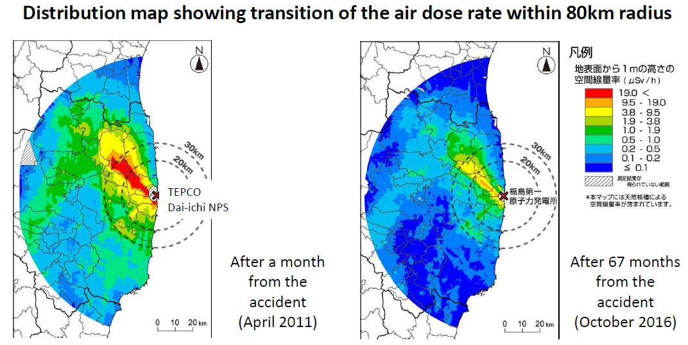
Figure 6 - Reduction in airborne radiation in and around Fukushima prefecture as of Feb 13, 2017, NSR
Airborne radiation monitoring within the SDA and the difficult central region varies considerably. Reference to Figure 6 indicates an existing yellow zone of 33 to 83 mSv/yr. The Fukushima Office for Environmental Restoration estimates that by 2022 this zone will have further reduced to 20 to 50mSv/yr with a few very small points remaining in the 50 to 100mSv/yr range.
Most attention has been to the restoration of farm land and it was noted on our field trip that a stripped paddy field had an airborne radiation level of 3mSv/yr yet only 30 metres away, under the deciduous forest canopy shown in Figure 7, the value was 12mSv/yr
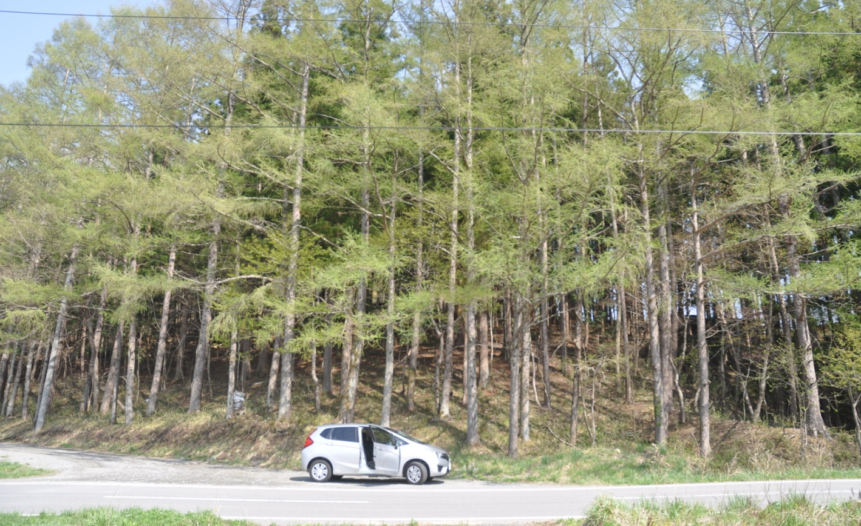
Figure 7 - Deciduous Forest

In conclusion, I came to this area to find out if radiation levels, human trauma and the extreme issues that have been reported in the Australian media were being played out in these communities. In Australia the style of reporting of the meltdowns has heightened the fear of nuclear energy. The reporting is generally alarmist and devoid of good science or objective data.
Unfortunately, as reported by Shunichi Yamashita, it would appear that anxiety and disruption to life in and around Fukushima is hurting people far more than radiation itself. Shunichi is a professor and vice-president at Nagasaki University and the radiation health management adviser for Fukushima prefecture. He has studied the health effects of radiation all his working life and he has real skin in the game. He was born in Nagasaki seven years after the Americans dropped an atomic bomb on the city and some 3 kilometres away from his future mother who was 16 years old at the time. His mother is now 88 and lives in his house.
Shunichi stated publicly that there should be no apparent health effects when exposure was below 100 mSv/yr. He also thinks that during the accident more than 99 per cent of people in the area received below 5 mSv, and the highest exposure was only 25 mSv. He had told the government that people could start to return after a month after the evacuation however his advice has not always been well received. He believes the delay however has fed the fears.
Many people remain in an uncertain situation, frightened that they or their children will get sick, and unable to resume their lives. Adults are experiencing depression, sleep loss and anxiety. Their children are also anxious and school performance has suffered. There have been more than 80 suicides linked to the accident and the evacuation. But there have been no deaths or sickness from direct exposure to radiation. The facts remain that no-one has died in Japan as a result of radiation from these meltdowns and the overwhelming balance of probability is that no-one ever will. A large question mark exists over the necessity to evacuate the region to the extent that was carried out.
What I have observed therefore is that the Japanese people in response to a collective anxiety have set some extreme standards in the rehabilitation of the land. This may also be influenced by cultural factors and the nation's need to atone for an assault on the land. With $40 billion spent to date however, there can be no economic benefit in terms of farming income.
To some extent this is a luxury that only an advanced nation can impose and I really wonder if there is any net benefit. Perhaps within their national values it's the type of reconciliation that's required. In a larger sense however I find it hard to reconcile these environmental demands against this nation's failure to act effectively on global warming.
The very low levels of radioactivity allowed in food do not appear to be informed by good science. The new values have set limits for radioactive caesium of 10Bq/litre for drinking water, 50Bq/litre for milk, 100 Bq/kg for general foods including seafood and 50 Bq/kg for infant food. This all has the aim of ensuring consumers do not exceed an incremental dosage from radiocaesium of 1mSv/yr by a very wide margin.
Radiation levels within parts of the Special Decontamination Area are deemed too be high to lift the evacuation orders however, realistically this limitation is confined to a small geographic zone that was never highly populated. Some of the younger generation will redirect their lives and many will not return.
The Fukushima prefecture and the SDA in particular will continue to experience the rehabilitation and repopulation of the region over a number of decades.
The Fukushima incident remains a significant industrial accident but it cannot be classified as the national catastrophe portrayed in the international press. The tragedy is the fear that has been engendered in part by the extreme protection measures that have been carried. This has reinforced fear rather than reduced it.

